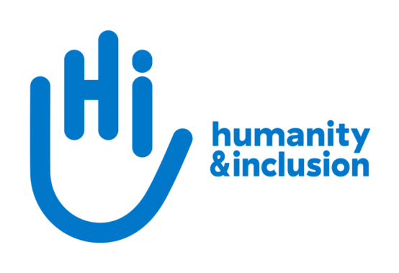

Programme Funding Officer

Application pack

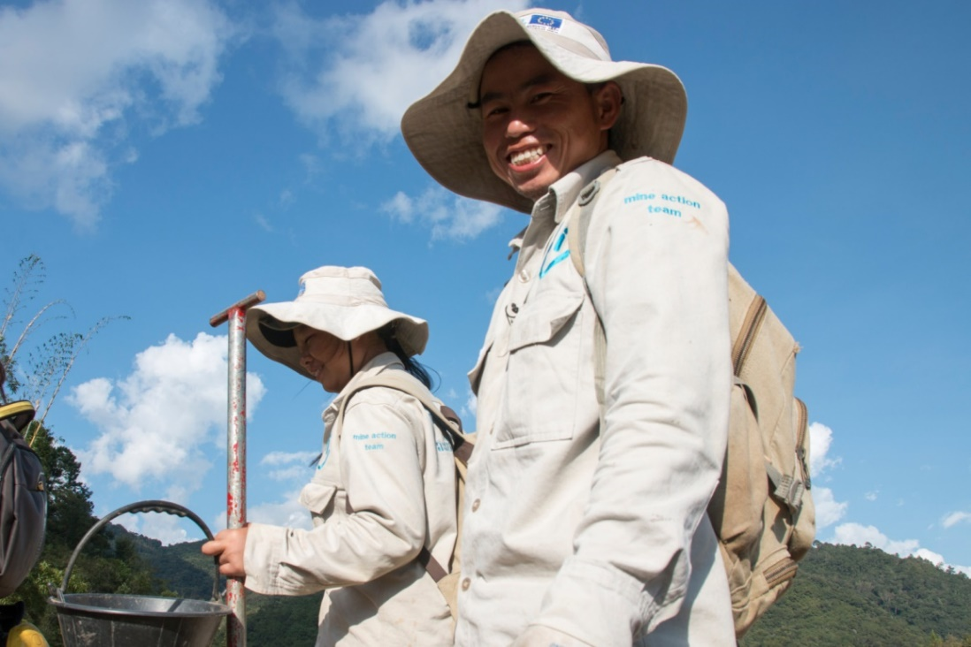

HI de-miners in Houaphan Province, Laos ©N.Lozano Juez/HI

Do you want to improve the lives of people with disabilities and vulnerable people?
Humanity & Inclusion (HI) is an award-winning international humanitarian and development organisation. Working alongside people with disabilities and vulnerable populations, we take action and raise awareness in order to respond to their essential needs, improve their living conditions and promote respects for their dignity and fundamental rights.

Our UK team is looking for an enthusiastic and committed individual to join us as a Programme Funding Officer (PFO). This is an exciting and varied role working across the funding cycle from the early stage of new opportunities through to grant management. You will be regularly in touch with our country teams, supporting them to engage with UK institutional donors in-country and advising them on compliance for both grants and commercial contracts. You will also get a chance to support partnership development, as well as get involved in advocacy and policy influencing. If this sounds like the next role for you, we’d love to welcome you to our friendly and dedicated team.

About Humanity & Inclusion (HI)

HI is co-winner of the 1997 Nobel Peace Prize for its work on the Mine Ban Treaty. We were also awarded the 2011 Hilton Humanitarian prize in recognition of our contribution to alleviating human suffering and supporting the most vulnerable people.
Grace, 5, was born with a congenital disability. She lives in Kakuma refugee camp. Having received a prosthesis from HI, she goes to school and can play like any other child. She wants to be a teacher when she grows up. Here she is with Stella, her HI physiotherapist.

©Patrick Meindhardt/HI

Outraged by the injustice faced by people with disabilities and vulnerable populations, we aspire to a world of solidarity and inclusion, enriched by our differences, and where everyone can live in dignity.

Respect for the rights of people with disabilities has been at the heart of HI’s approach since it was founded in 1982. Almost forty years on, our organisation is still working and fighting around the world to improve the living conditions of people with disabilities and other vulnerable people and to ensure that their fundamental rights are respected.

About Humanity & Inclusion UK (HI UK)

HI UK is a member of the Humanity & Inclusion Network, which is comprised of a Federation and eight national associations. As part of the Network, HI UK works towards a common strategy while maintaining a distinct identity as a British organisation. The Federation is responsible for implementing the Network’s social missions in around fifty countries. It operates under the names “Humanity & Inclusion” or “Handicap International”, depending on the country.

HI has an ambitious delivery plan in the UK, as part of our 2016-25 strategy, For More Solidarity and Inclusion in the World.

Equal opportunities policy

HI UK is committed to diversity and inclusion. We recognise that discrimination shapes the opportunities that many people have in society and that people have different needs in order to realise their full potential. Addressing this requires organisations to be proactive in creating environments that encourage the inclusion and development of all. Though we still have a long way to go, inclusion is central to our identity at HI UK and we are strongly committed to the continuous work that it requires.

We are particularly interested in hearing from candidates with disabilities and/or from Black and minority ethnic backgrounds, to help make us more representative. If you have a disability and meet the minimum requirements for the role, we will guarantee you an interview.

Employee Benefits

- All employees are entitled to 28 days’ holiday per year in addition to UK public holidays (pro rata for part-time employees). Colleagues may also take an additional day off for their birthday.

- Training and development opportunities are open to all staff and will be provided in order to support them to fulfil their roles.

- We value all our employees and strive to support them in their professional lives. This includes offering flexible-working opportunities, including home-working, flexible hours and two days’ volunteering leave each year.

- We offer a competitive workplace pension scheme, matching contributions up to 6% of gross salary.

- We are positive about employing persons with disabilities and are proud to be accredited as a Disability Confident Employer.

- We offer a Worklife Support Employee Assistance Programme, which provides confidential information, support and counselling.

- We strive to create a diverse and inclusive working environment and we are constantly looking at ways to improve our policies, processes and culture.

- Our office is conveniently located in SE1 with great transport links to Waterloo, Blackfriars, London Bridge and the London Underground. We run a hybrid-working approach, with colleagues expected to work from the office at least six days a month.

JOB DESCRIPTION

1. JOB TITLE Programme Funding Officer (PFO)

2. ORGANISATION Humanity & Inclusion UK (HI UK)

3. SALARY £36,440 per annum

4. REPORTING TO Head of Institutional Relations

5. DURATION Permanent

6. LOCATION London (SE1) with some remote working
The applicant must have the right to work in the UK

7. BACKGROUND INFORMATION AND PURPOSE OF THE POST

The Institutional Relations team is responsible for donor engagement and influencing, institutional funding, and partnerships in the UK. It comprises the Head of Institutional Relations and three Programme Funding Officers.

As part of HI’s 2016-2025 strategy, we have ambitious targets for growth in institutional funding from UK donors, and more broadly, a focus on building strategic relationships with key UK donors and partners. Given the changing external funding environment and evolving context in the UK, we are looking for an individual who is willing to be flexible and adapt to the context in order to meet the organisation’s needs and have the biggest impact for people with disabilities.

The main purpose of this post is:
- Improving our track record for UK and other funding by increasing internal understanding of donors and funding mechanisms in your portfolio, supporting high quality submissions, grant management and donor compliance
- Strengthening relationships with, and generating and managing funding from UK and other institutional donors and partners

8. MAIN DUTIES AND RESPONSIBILITIES

General

Promoting our work and building relationships with institutional donors
Supporting the work of the Head of Institutional Relations, you will have sound knowledge of the donors and funding mechanisms in your portfolio, and contribute proactively to influencing their funding strategies and priorities. Duties include:
- Maintain a good understanding of HI’s programmes, strategy and approach and communicate this externally
- Identify and build relationships with a portfolio of large public and private institutional donors and their key suppliers (e.g. INGOs and for-profit development companies), mobilising colleagues from UK and across the global organisation as required
- Work with country programmes to develop country-level action plans to engage with local representatives of UK donors and partners, in order to strengthen in-country relationships, influence donors’ country-level plans and access in-country funding opportunities. This will also involve supporting the development of multi-year operational plans and advise on the funding possibilities offered by UK institutional donors
- Anticipate future trends and the expectations of the donors and funding mechanisms in your portfolio, influence their policies and strategies, and negotiate and consult with them on institutional funding matters, in liaison with the appropriate colleagues from the UK team and federal network
- In coordination with the Head of Institutional Relations and the Chief Executive, monitor and where needed, contribute to collective work and advocacy initiatives in collaboration with partners and INGO networks (such as the Start Network and targeted Bond groups) with the aim of raising HI’s profile and influencing UK donors in line with our influencing priorities

Generate and manage institutional funding from UK donors
You will follow and champion HI’s internal institutional funding procedures to identify and analyse funding opportunities from UK sources, contribute to project submissions, and carry out grant management duties. You will:
- Monitor, identify, analyse and communicate all relevant funding opportunities from donors in your portfolio (including development and humanitarian grant opportunities and commercial contracts). This will involve facilitating internal go/no go decision-making for new opportunities and advising, and supporting programme colleagues on positioning and consortium-building when relevant
- Lead the review and analysis of the requirements in new funding agreements and contracts, advise internal stakeholders on compliance and ensure appropriate contract negotiation and due diligence processes are followed
- Implement internal procedures for contract/grant management and support the submission of reporting and payment requests according to donor requirements

Improve our track record for UK institutional funding
You will be responsible for increasing internal understanding of UK donors and funding mechanisms in your portfolio, supporting high quality strategic submissions and donor compliance. You will:
- Create internal communications, train and brief finance, programme and technical staff (including country programmes) on the donors in your portfolio, ensuring they have the tools and knowledge to comply with donor rules, understand donor priorities and focus areas, and maximise the potential for funding
- Support proposal development, advising on donor requirements, expectations and preferences
- Build strong relationships and internal links with technical and programme teams and contribute to internal working groups on issues related to institutional funding

Other duties

- Maintain a positive and collaborative working relationship with HI UK colleagues and the Federal Institutional Funding, and Operations teams
- Actively contribute to the HI UK operational plan and team work plans, and internal staff meetings
- Ensure high quality, accurate internal reporting and information management for your portfolio
- Keep abreast of developments within the sector by liaising with counterparts in other NGOs, and relevant networks
- Represent HI UK at external forums and meetings when relevant
- Any other activities commensurate with the level of the post, as may be required by the Chief Executive or Head of Team

Conduct and safeguarding

Respect and dignity of all the people we support and come into contact with are at the heart of HI’s approach. All employees, volunteers (including trustees), partners, suppliers and consultants working with HI UK are expected to adhere to our Code of Conduct and related policies.

Our commitment to safeguarding means we seek to ensure that no harm comes to people as a result of contact with the organisation’s programmes, operations or people. This means ensuring the safety and protection of groups, including children and vulnerable adults, with whom the organisation is in contact, establishing safe and respectful workplaces that are free from harassment, abuse and discrimination, and maintaining HI’s reputation and high standards by preventing, addressing and learning from instances of wrongdoing.

This post is Safeguarding Level 1, which means no DBS check is required (unless the content of the post changes).

9. PERSON SPECIFICATION
ESSENTIAL
Relevant grant management experience with international charities/NGOs, including at least one year’s experience managing an institutional funding portfolio, or one year’s experience implementing grant funded programmes
Proven track record of securing, implementing and monitoring grant-funded projects from large institutional donors
Proven experience of developing and implementing policies, procedures and supporting tools for a wide range of audiences
Excellent attention to detail
Proven ability to design, deliver and edit high-quality written documents
Evidence of strong interpersonal skills to guide programme teams and to work cross-departmentally with technical and programme colleagues
Excellent negotiation and communication skills for a range of audiences, including donors and external INGO networks
Ability to carry out sound strategic analysis, taking into account internal and external considerations
Strong planning skills and an ability to work under pressure, with an ability to prioritise, and meet standards and deadlines
Excellent IT skills (Word, Excel, PowerPoint, Outlook, Teams)
Ability to work on own initiative when appropriate and to seek guidance when necessary
Willingness to travel within Europe and to field locations for periods of up to two weeks
Passion for improving the lives of the world’s most vulnerable people
Collaborative team player
Positive about creating and maintaining an inclusive and protective environment for everyone that comes in contact with the organisation
Fluent in English
DESIRABLE
Experience of working in an international multi-cultural charity/organisation
Lived experience of disability or from one of our countries of operation
French language proficiency
Track record of working with, securing or managing funding from DFID/FCDO/FCO, IrishAid, JOA, Start Network
Experience or studies in international development, social sciences, public health or any other relevant domain
Previous experience providing face to face and/or distance training
Previous experience with commercial contracting, particularly funded by DFID/FCDO
Understanding of key humanitarian, development and funding issues (i.e. value for money, theory of change, partnership development, humanitarian financing, localisation)
Experience of consortium working and developing and monitoring consortium proposals

We genuinely value diversity, and are looking to build a team of people with a wide of range of personal and professional experience. If you don’t meet all of the criteria listed above, but feel you would be a good candidate for this role, please apply. If you would like an informal conversation about this, please do send us an email or call us – we would love to hear from you.

APPLICATION PROCESS

To apply, please send your CV and a covering letter by email or post. Please also complete our Diversity monitoring form online.

By email: recruitment.uk@hi.org
By post: Humanity & Inclusion UK (Recruitment), 9 Rushworth Street, London SE1 0RB

If you disclose a disability during your application process and you meet the minimum criteria for the role, we will contact you to discuss any reasonable adjustment you might need at the interview. However, if you have not disclosed, please be aware that any candidate invited for interview will be asked if any reasonable adjustments are needed.
If you wish to disclose a disability please do so in your covering letter.

Closing date: 28th January 2024
Remote interviews, which will include a short written exercise, are planned for Wednesday 31st January, Thursday 1st February and Friday 2nd February.

For further information, please contact Humanity & Inclusion UK on 0870 774 3737 or by email at recruitment.uk@hi.org.

