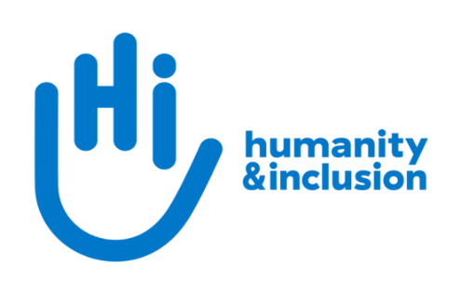

Fundraising Volunteer

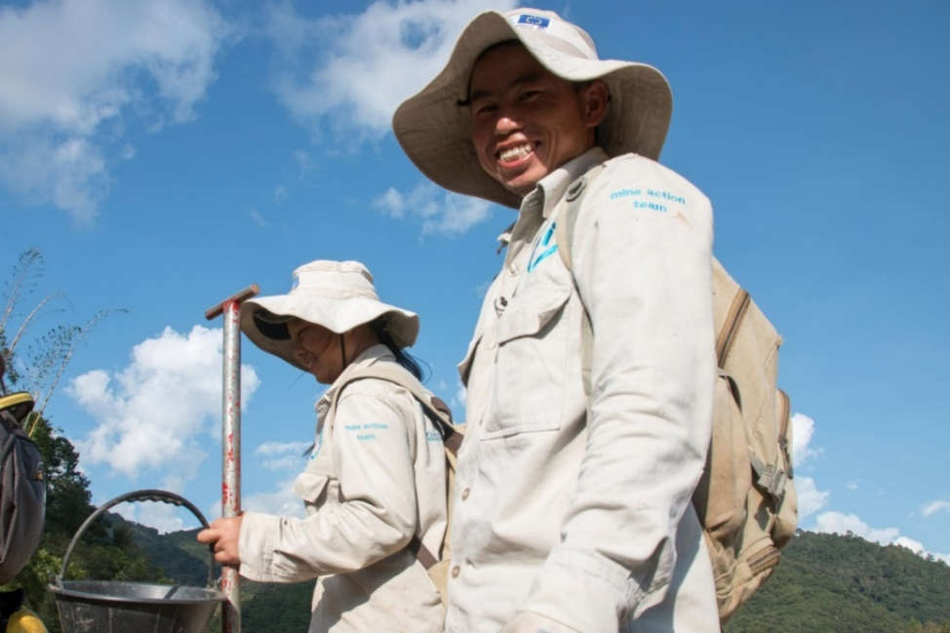
Application Pack

HI de-miners in Houaphan Province, Laos ©N.Lozano Juez/HI

Do you want to improve the lives of people with disabilities and vulnerable people?

Humanity & Inclusion (HI) is an award-winning international development organisation working in situations of poverty and exclusion, conflict, and disaster. Working alongside people with disabilities and other vulnerable people, we respond to their essential needs, improve their living conditions, and promote respect for their dignity and fundamental rights.

We are looking for a Fundraising Volunteer to join our small, dynamic and ambitious team with big plans. You will be providing administrative, research and income-generating support to our Private Fundraising team. Your work will be essential in helping our teams provide excellent donor care to our supporters, as well as assisting with the smooth running of our office and fundraising activities.

By volunteering with us, you will have the opportunity to gain first-hand experience of working for a charity and will contribute to our work supporting people with disabilities and other vulnerable groups worldwide, while learning new skills.

The main purpose of this role is to:

- Undertake administration tasks to support fundraising efforts.
- Support a variety of income-generation functions, including individual giving, event fundraising, trust and foundations grant-making, and corporate giving.
- Support communication and media outreach, including identifying and maintaining journalists/contacts, researching new outreach prospects, and writing press releases.

Key tasks you may be able to support:

- Support the Individual Giving and Communications team in supporter care and social media activities.
- Ad hoc research tasks on donor engagement and retention and supporter care.
- Create engaging content for a new campaign aiming to bring in new potential donors to HIUK.
- Research new opportunities to partner with high-net-worth individuals, companies, and trusts & foundations, who are the most relevant match for HI’s mission.
- Update the database of donors and prospective donors, for example with contact information, interest areas, and recent communications, to ensure our records are up to date and accurate.
- Maintain and update our database of journalists, outlets, and contact information for successful media outreach.
- Support with the creation of broadcasting segments and press releases.

Experience required

Essential

- Excellent attention to detail.
- Competent in the use of Microsoft Office (especially Word, Excel and Outlook).
- Strong planning and organisational skills.
- Excellent spoken and written English.
- Initiative and the ability to work independently.
- A positive attitude to working as part of a small team.

Desirable

- An interest in charitable activities.
- Lived experience of disability.
- Previous data-entry experience.

Hours

To be agreed with the volunteer, in accordance with availability. It is hoped that the volunteer may be available for at least one day per week.

This is a voluntary position but contributions to lunch (up to £8/day) and travel costs (up to £14.40/day) are made on presentation of receipts.

Location

Humanity & Inclusion UK’s office is situated in Southwark, London. It has an open-plan setting.

Please note that we are unable to offer remote volunteering opportunities.

How to apply

Fill in the volunteering application form and send it along with your CV by email or post to recruitment.uk@hi.org or Humanity & Inclusion UK (Volunteering), 9 Rushworth Street, London, SE1 0RB.

For further information, please contact us on 0870 774 3737 or by email at recruitment.uk@hi.org.

If you disclose a disability during your application process and you meet the minimum criteria for the role, we will contact you to discuss any reasonable adjustments you might need at the interview. However, if you have not disclosed, please be aware that any candidate invited for interview will be asked if any reasonable adjustments are needed. If you wish to disclose a disability, please do so in your covering letter.

Equal opportunities

HI UK is committed to diversity and inclusion. We recognise that discrimination shapes the opportunities that many people have in society and that people have different needs in order to realise their full potential. Addressing this requires organisations to be proactive in creating environments that encourage the inclusion and development of all. Though we still have a long way to go, inclusion is central to our identity at HI UK and we are strongly committed to the continuous work that it requires.

We are particularly interested in hearing from candidates with disabilities and/or from minority ethnic backgrounds, to help make us more representative. If you have a disability and meet the minimum requirements for the role, we will guarantee you an interview.

